CURRICULUM VITAE 2023
Last Name: Angles

First name: Maria Valeria
Degree: Medical Doctor |  |  | Specialty: Dermatology-Pediatric Dermatology

Professional Address: Pte Perón 4272, Buenos Aires, Argentina, C1199ABD

Education and training:

Institution Name and location |  | Degree Obtained/date |  |  | Study area
Buenos Aires National University Medicine Faculty |  | Medical Doctor (Dec-1993) |  |  | Medicine
Buenos Aires National University Medicine Faculty |  | Pediatrics -2004  Pediatric Dermatology -2007  Dermatology-2009 |  |  | Medicine
Professional Experience (Current Position and last 5 years)

Position/title | Institution Name | Date
Staff member, Dermatology Department. | Hospital Italiano de Buenos Aires  Gascon 450, CABA, Argentina | Since Julio 2007
Head of Pediatric Dermatology | Hospital Italiano de Buenos Aires  Gascon 450, CABA, Argentina | Since January 2018

Professional Experience in clinical trials: * Yes No
 | Study Phase  (I-IV) | Position | Date of study conduction

Study | Study Phase  (I-IV) |  |  | Position |  | Date of study conduction
ESTUDIO MULTICENTRICO, RANDOMIZADO, DOBLE CIEGO, DE DISEÑO PARALELO, PARA EVALAUR LA SEGURIDAD Y EFICACIA INICIAL DE PROGUANIL 3% FRENTE A CONTROL CON VEHICULO EN SUJETOS CON ACNE VULGARIS. | II |  |  | subinvestigator |  | 2011
Traducción y adaptación transcultural de un cuestionario internacional estandarizado sobre la usabilidad de la telemedicina. Posición: subinvestigadora. Lugar: Hospital Italiano de Buenos Aires | Observational |  |  | subinvestigator |  | 2018
Validación de un cuestionario estandarizado sobre la usabilidad de la telemedicina. Posición: subinvestigadora. Lugar: Hospital Italiano de Buenos Aires. Inicio: 2018 Investigación en curso | Observational |  |  | subinvestigator |  | 2018
Prevalencia de Dermatitis atópica en adultos en un hospital de Comunidad. Posición: Investigadora Principal. Lugar: Hospital Italiano de Buenos Aires. Inicio 2018. Para aprobación del CEPI | Observational |  |  | subinvestigator |  | 2019
“GLOBAL AWARE – Mercados Emergentes (ME) (Adultos Con Dermatitis Atópica que Reportan Su Experiencia en Mercados Emergentes) – OBS15591”. | Observational |  |  | Principal investigator |  | 2020
Utilización de upadacitinib en pacientes adultos y adolescentes con  dermatitis atópica moderada a severa en el mundo real (AD-VISE) | Observational |  |  | subinvestigator |  | 2022
ICH/GCP training: SI *¨ NO o
Protecting human disease participants NIH office extramural research, program 10/05/2016
Postgraduate course in Fundamentals of research and standards of good clinical practice, held at the IUHI from April 17 to July 10, 2018, with final exam.

Curso de Buenas Prácticas clínicas. Instituto Universitario del hospital Italino. 17 de marzo del 2021
Certificado otorgado por el Comité de Etica de Protocolos de Investigación y el Departamento de Investigación del HIBA
El presente curso incluye la normativa nacional (Disposición 6677/10 ANMAT y Resolución 1480/11 Ministerio de Salud de la Nación.

Publications (last 5 years):
1- Sánchez J, Ale IS, Angles MV, Fogelbach GG, Jansen AM, Takaoka R, Borzutzky A. Healthcare Disparities in Atopic Dermatitis in Latin America: A Narrative Review. Dermatol Ther (Heidelb). 2022 Dec 23:1–18.
2- Antonietti C, Angles MV, Giachetti A, Diaz MS, Gloser D, Juszkiewicz E, Parrales Villacreses M, Mazzuoccolo L, Parisi C. Atopic dermatitis in children and adolescents seen at a general hospital in the City of Buenos Aires. Arch Argent Pediatr. 2022 Dec 1:e202202639.
3- Echeverría C, Angles MV, Larralde M, Luna PC, Mazzuoccolo LD, Moreno P. Impact of atopic dermatitis on quality of life: a large web-based survey from Argentina. Rev Fac Cien Med Univ Nac Cordoba. 2022 Dec 21;79(4):369-373.
4- Luna PC, Debernardi ME, Echeverría CM, Angles MV, Mazzuoccolo LD. ECHO project in atopic dermatitis in Argentina: An innovative strategy to reach underserved areas with up to date knowledge, first year of experience. An Bras Dermatol. 2022 Jul-Aug;97(4):443-447.
5-Colussi G, Inda D, Zin Y, De Matos Lima S, Angles MV, Bruey S, Lanteri Sambrizzi A, Mazzuoccolo L, Luna D, Plazzotta F. Designing an Atopic Dermatitis Community that Integrates Patient Self-Uploaded Information into the EHR to Optimize Follow-up. Stud Health Technol Inform. 2022 Jun 6;290:540-542.
6- Angles MV, Antonietti CA, Torre AC, Juszkiewicz Franzé E, Mazzuoccolo LD, Parisi CAS. Prevalence of atopic dermatitis in adults. An Bras Dermatol. 2022 Jan-Feb;97(1):107-109.
7-Bibiloni N, Torre AC, Angles MV, Terrasa SA, Vazquez Peña FR, Sommer J, Plazzotta F, Luna D, Mazzuoccolo LD. Validación de un cuestionario en español sobre la usabilidad de la telemedicina [Validation of a Spanish questionnaire on telemedicine usability]. Medicina (B Aires). 2020;80(6):649-653. Spanish.
8- Torre AC, Bibiloni N, Sommer J, Plazzotta F, Angles MV, Terrasa SA, Luna D, Mazzuoccolo LD. Traducción al español y adaptación transcultural de un cuestionario sobre la usabilidad de la telemedicina [Spanish translation and transcultural adaptation of a questionnaire on telemedicine usability]. Medicina (B Aires). 2020;80(2):134-137.
9-Máspero J, Angles MV, Ardusso L, Brancciforte M, Castro C, Cruz Iturrieta C, Chouela E, De Gennaro MS, Fernández Bussy R, Galimberti ML, Galimberti RL, Gattolin G, Luna PC, Magariños G, Marini MG, Maskin M, Plafnik R, Raimondo N, Russo JP, Sevinsky L, Stringa MF. Análisis de una serie de casos de pacientes adultos con dermatitis atópica severa tratados con dupilumab en Argentina [Analysis of a case series of adult patients with severe atopic dermatitis treated with dupilumab in Argentina]. Rev Fac Cien Med Univ Nac Córdoba. 2020 Jun 9;77(2):94-99.

English Language:

Read | YES | Write | YES | Speak: | YES

Signature  Maria Valeria Angles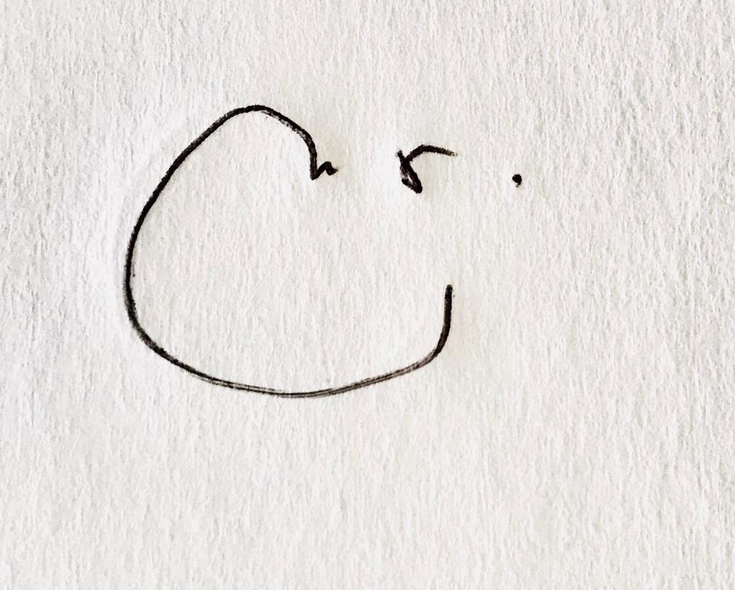 | Date  16 de enero 2022

